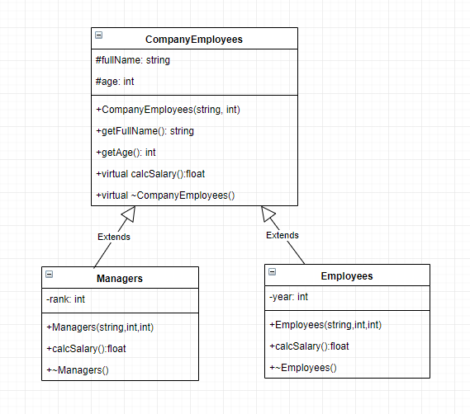

Write a C++ program for a Company’s payment system.

* **CompanyEmployees** class is an **abstract** class. The ***calcSalary()*** function is a pure function. And the destructor displays a message like "(fullName) has left the job at the age of (age)"
* **Managers** class inherited from CompanyEmployees class. The ***calcSalary()*** function calculates and returns the manager’s salary. Each manager starts with 5000 TL initial salary. To calculate the final salary; add %rank of the initial salary to the initial salary. The destructor displays a message like "(fullName) has left the Management Department at the age of (age)"
* **Employees** class inherited from CompanyEmployees class. The ***calcSalary()*** function calculates and returns the employee’s salary. Each employee starts with 2000 TL initial salary, and their salaries increases 1000TL every 5 year period. The destructor displays a message like "(fullName) has left being employee at the age of (age)"

Write a ***display()*** function that is outside of all classes. It takes 1 parameter. If its parameter is a Managers class object, it will show Manager’s properties. If its parameter is an Employees class object it will show Employee’s properties.

In **main** function, create a CompanyEmployees array that holds a Managers object that its fullName is Kobe Bryant with age 42 and rank 3 and an Employees object which its fullName is Stephen Curry with age 32 and year of the work is 2. Call the display function with using all array elements by considering the sample run below.

**Sample Run:**

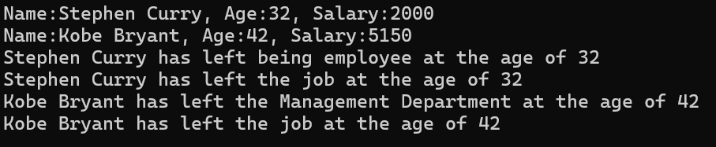

1. Write a C++ code that has three classes.

* The first one is named “***Student***” and has the following data member
* studentId (integer type)

member functions:

* a constructor to initialize the data member.
* int getstudentId() that returns studentId .
* The second one is named “***Teacher***” and has the following data member
* registrationNo (integer type)

member functions:

* a constructor to initialize the data member.
* int getregistrationNo() that returns registrationNo.
* The third one named “***Assistant***”, has a constructor with 2 parameters to initialize all of the data members.

Use **Multiple Inheritance**, consider a base class Student and Teacher, derived class Assistant.

Create an object from the Assistant class and output the following information:

studentId = 9753, registrationNo = 987.